Does a one-pool water-balance model improve forecasts of Edwards Aquifer head? A scored test at J-17
Research article (empirical forecast evaluation)
Prepared for submission to Groundwater

Author information withheld for double-anonymous peer review.
Corresponding-author details to be completed by the author at submission.
30 August 2026
Contribution statement. A preregistered, scored forecast evaluation on the 1934–2023 J-17 index-well record finds that no causal module beats a simple AR(1) or persistence on out-of-sample RMSE at short horizons, with the information-layer rent quantified by an oracle benchmark.
Keywords. viability; forecast evaluation; Edwards Aquifer; J-17; model ablation; persistence

Abstract
This evaluation follows a preregistered retention rule: additional model structure is retained only when it improves early warning, out-of-sample prediction, or intervention selection. This paper applies that test to the San Antonio Pool of the Edwards Aquifer, Texas.
The predictand is the calendar-year mean of daily-high water elevation at the J-17 index well (TWDB 6837203), 1934–2023. Nested models issue fixed-window and rolling-origin forecasts. Recharge (USGS/Puente) and well pumpage (Edwards Aquifer Authority Table 1) enter as candidate drivers. Comal Springs discharge is scored only after model retention is frozen.
One-year rolling root-mean-square error (RMSE) is 13.23 ft for last-value persistence and 12.84 ft for a univariate AR(1); the AR(1) is retained as an output-only model, by a margin of 0.39 ft. The causal stock-flow specification, which persists the most recent recharge and pumpage, has RMSE 14.70 ft and is rejected. A climatological stock-flow variant reaches 12.28 ft but is listed only and then declined on class grounds: under constant fluxes it collapses to an affine AR(1), so its numerical advantage is not extra structure. Residual and delayed variants do not improve on persistence. Recharge has lag-1 correlation 0.17; using last year’s recharge as next year’s recharge therefore adds variation that is only weakly related to the increment being forecast. When the same map is given realized future recharge and pumpage, RMSE falls to 7.55 ft — an information-layer rent of nearly half the persistence error that no signal available at the annual origin recovers. Climate-informed recharge forecasts known at the origin — September–November Niño 3.4, lagged climate-division precipitation, and their combination — lie within 0.02–0.13 ft of AR(1) at the one-year horizon, AR(1) on recharge itself being 0.4 ft worse, and all four have higher RMSE than persistence at the five-year horizon (where training-mean climatology, 16.80 ft, beats persistence, 21.11 ft). Contemporaneous precipitation tracks recharge ($r=0.78$), but next year’s precipitation is not known at the forecast origin. ENSO and last year’s precipitation are not substitutes for it.
No two-pool, solute, or institutional-kernel claim is made. The evaluated specification is a one-pool approximation of the aquifer’s head map. The two-pool exchange module remains conditionally admissible and is not closed here.

1. Introduction
Forecasting aquifer heads at index wells is a recurring operational problem of groundwater management: drought-stage declarations, springflow protection, and permit adjustments all key on forecasted water levels. The methodological literature has responded with an increasingly rich inventory of groundwater-level forecasting models, from conceptual water balances to data-driven regressions and, prominently, artificial-neural-network and wavelet–neural-network conjunction models trained on measured heads (Daliakopoulos et al. 2005; Adamowski and Chan 2011). Whether added structure improves out-of-sample forecasts — as opposed to in-sample fit — is a separate, testable question, and the general forecasting literature has made the benchmark discipline explicit: across the M4 competition’s 100,000 series, sophisticated methods did not uniformly beat simple statistical baselines (Makridakis et al. 2020). The minimal bar for any proposed module is therefore the forecast that nothing changes — last-value persistence — together with the training mean.
This evaluation follows a preregistered retention rule: additional model structure is retained only when it improves early warning, out-of-sample prediction, or intervention selection. The instrument is a scored model-ablation framework — a ladder of nested water-balance models evaluated against the two naive baselines. Complexity is kept only if it improves a preregistered score, decided on out-of-sample error on the predictand itself.
We selected the Edwards (Balcones Fault Zone) Aquifer J-17 index well because its long (1934–2023) daily head record, its explicit institutional thresholds, and its management relevance make it a natural test bed for scored forecast evaluation. The San Antonio Pool passes each design criterion the evaluation requires: a measured basin state, independent recharge, dated implementable use, a declared threshold, and a measured service series. The aquifer is also a karst system in which regional flow has long been represented — and debated — through equivalent porous media and lumped approaches (Scanlon et al. 2003), which makes the fate of a deliberately simple one-pool water-balance map a live hydrogeologic question rather than a straw man.
The question is whether stock-flow, residual, delay, or climate-informed recharge modules reduce forecast error of J-17 annual-mean head relative to last-value persistence and to a univariate AR(1). The climate modules enter because El Niño/Southern Oscillation (ENSO) phases shift North American precipitation patterns (Ropelewski and Halpert 1986): September–November Niño 3.4 and lagged climate-division precipitation are precisely the signals observable at an annual forecast origin.
A companion study under separate review applies the same scored design to a marine fishery stock (Northern cod, NAFO 2J3KL); the two systems’ scores are never pooled, and no retention verdict is transferred between them. The paper does not assess whether the aquifer is sustainable, does not close the two-pool exchange module’s blocking list, and does not treat springflow or reconstructed storage as co-primary predictands. No solute or water-quality module is opened.
The remainder of this article is organized as follows. Section 2 states the data and the specification. Section 3 defines the one-pool map and the model ladder. Section 4 states the evaluation design — windows, rolling origin, scores, and the retention rule. Section 5 reports the results: the series (Section 5.1), the fixed windows (Section 5.2), the rolling origin (Section 5.3), climate-informed recharge (Section 5.4), and the service series scored after the retention freeze (Section 5.5). Section 6 discusses the findings and their limits, and Section 7 concludes. Data and code availability and the references close the paper.

2. Data and specification
Table 1 types each field as follows: D, data; E, empirical construct; M, model; N, normative threshold.
Table 1. Specification $Ω_{SA}$ — the San Antonio Pool specification: J-17 annual-mean elevation, 1934–2023.
Field | Contents | Type
System | Edwards Aquifer, San Antonio Pool, indexed by J-17 | D
$z_{t}$ | Calendar-year mean of daily-high J-17 elevation (ft AMSL) | D
Well | TWDB 6837203 / EAA AY-68-37-203 | D
Domain | San Antonio Pool; calendar years 1934–2023 | D
Physical threshold | Head high enough that Comal Springs does not cease ($≈618$ ft; 1956 daily minimum $612.51$ ft) | N / E
Institutional threshold | EAA Stage I, 10-day mean J-17 $<660$ ft (in force after 2007) | N
Disturbance | Recharge pulses; unmodeled karst; Uvalde–San Antonio exchange | M
Implementable use | Pre-EAA pumping; post-1996/2007 permits and critical-period management | E
Service series | USGS 08168710 Comal Springs annual mean discharge (cfs) | D
The predictand is a measured well series. It is not a GRACE or G3P storage reconstruction, a MODFLOW or GWSIM inversion, EAA reconstructed storage, the J-27 Uvalde index, San Marcos Springs, or total spring discharge.
Stage I at 660 ft is a 2007 institutional rule and is not applied as if it existed in 1956. Cessation of Comal Springs near 618 ft is a physical service bound. The indicator $1\{H<660\}$ on the annual mean is a coarse Brier proxy, not the Authority’s 10-day declaration.
Annual means use all available daily highs. Years with fewer than 240 observations are dropped. 1935 ($n=258$) and 1939 ($n=242$) are incomplete-coverage means. Missing days are not interpolated. The published pre-continuous composite (Beverly Lodges extension) is used as issued. Values from 2023 onward include provisional TWDB status R. The complete estimation panel ends in 2023.
Recharge $R$ is USGS total San Antonio-area recharge (${10}^{3}$ acre-ft yr$​^{−1}$), estimated by the Puente (1978) stream-loss method and independent of J-17 (Umphres and Choi 2025). Pumpage $P$ is well discharge from Edwards Aquifer Authority Table 1. Total spring discharge is stored and is not used as a driver. Climate predictors, used only in Section 5.4, are September–November Niño 3.4 (HadISST, anomaly relative to 1991–2020) and calendar-year precipitation in Texas climate divisions 06 and 07 (NCEI nClimDiv).

3. Forecast models
The one-pool map, with head clipped to $\left[610,710\right]$ ft, is
$$H_{t+1}=[H_{t}+α+β{\tilde{R}}_{t+1}+γ{\tilde{P}}_{t+1}+δH_{t}]_{clip}.$$
Forecasts are issued at the end of year $t$ from $\left(H,R,P\right)$ through $t$.
Table 2. Model ladder.
ID | Class | Fluxes at $t+k$ | Role
persist | baseline | — | ${\hat{H}}_{t+h}=H_{t}$
mean | baseline | — | training-window mean
M1 | autonomous | — | $H_{t+1}=a+φH_{t}$
M2 | causal stock-flow | last $\left(R_{t},P_{t}\right)$ persisted | candidate for retention
M2m | climatological stock-flow | training-mean $\left(R,P\right)$ | affine AR(1)
M3 | residual | as M2 | AR(1) residual on $ΔH$
M4 | delay | as M2 | starts from $H_{t−1}$
M2_oracle | diagnostic | realized future $R,P$ | excluded from retention
With constant fluxes, M2m reduces to $H_{t+1}=\left(1+δ\right)H_{t}+const$ and is therefore the same affine class as M1. A numerical advantage for M2m is not extra structure.
Climate-informed variants (Section 5.4) replace persisted $R$ by a one-step forecast of $R$ from information known at $t$: AR(1) on $R$, lagged Niño 3.4, lagged climate-division precipitation, or all three. A precipitation-oracle variant uses year $t+h$ precipitation and is excluded from retention. For horizons $h>1$, the one-step recharge forecast is held constant.

4. Evaluation
The primary score is RMSE of annual-mean J-17, in feet. Secondary scores are mean absolute error; Brier score for $1\{\hat{H}<660\}$, interpreted only for origins $≥2007$; and the sign-hit rate of $ΔH$ on fixed windows.
Fixed windows:
- Drought of record, drawdown: train 1934–1950, test 1951–1956.
- Drought of record, recovery: train 1934–1956, test 1957–1961.
- Pre-permit wet interval: train 1980–1990, test 1991–1995.
- Critical-period era: train 1997–2014, test 2015–2023.
Rolling origin: minimum 15 training years; horizons $h=1$ and $h=5$; $n=75$ and $n=71$ respectively.
A causal module is retained only if its primary RMSE is strictly less than that of persistence and strictly less than that of the next-simpler causal model. Diagnostic oracles are excluded from retention. The Comal series is excluded from retention. Retention is decided on $z$ only; the service series is scored after that decision is frozen.
The scoring protocols for Pass 1 and Pass 2 were frozen and dated (2026-08-25) before the corresponding RMSE tables were computed; the frozen protocol documents are archived with the analysis code. The design is a fixed computational protocol rather than a prospective clinical-style registration.

5. Results

5.1 Series
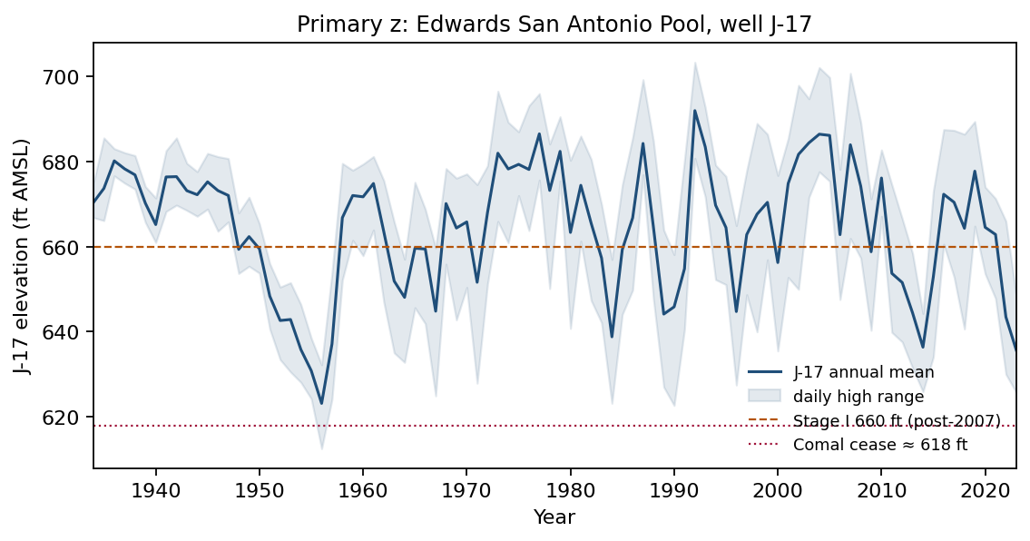
Figure 1
Figure 1. J-17 annual mean and daily-high range. 1956 mean $623.15$ ft, daily minimum $612.51$ ft. 1992 mean $691.96$ ft, daily maximum $703.31$ ft. 2023 mean $635.68$ ft. Annual mean is below 660 ft in 31 of 90 years. Daily minimum is below 618 ft in one year (1956).

5.2 Fixed windows
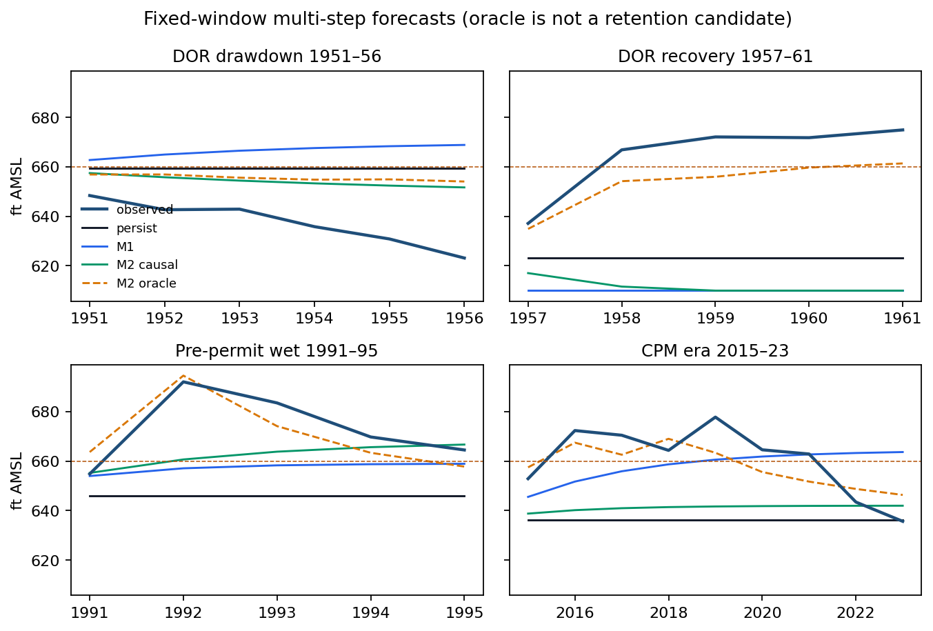
Figure 2
Figure 2. Multi-step forecasts from the end of each training window. The oracle (dashed) is diagnostic.
Table 3. Fixed-window RMSE (ft).
Window | persist | mean | M1 | M2 | M2m | M3 | M4 | oracle
Drawdown 1951–56 | 23.75 | 35.19 | 30.94 | 18.11 | 27.44 | 18.12 | 18.23 | 19.69
Recovery 1957–61 | 43.62 | 14.07 | 56.24 | 55.32 | 37.74 | 55.28 | 55.12 | 12.26
Pre-permit wet 1991–95 | 30.13 | 18.24 | 20.02 | 16.67 | 23.47 | 16.41 | 15.26 | 7.18
Critical-period era 2015–23 | 27.41 | 14.77 | 15.62 | 23.37 | 14.79 | 22.84 | 22.17 | 8.70
Bold marks the best model of the window (on the drawdown window the best causal model, M2, also beats the oracle). The train-mean baseline is the best non-oracle forecast on the recovery window (14.07 ft) and on the critical-period era (14.77 ft), consistent with its rolling five-year win; the residual-persistence rungs M3/M4 track M2 on the drawdown (18.12/18.23 versus 18.11 ft), M4 is the best causal model on the pre-permit wet window (15.26 ft), and both fail with the causal family on the recovery and critical-period windows.
The 1950s drawdown is a continuing low-recharge path. The last observed $R$ is already low, so causal M2 has lower RMSE than persistence (18 versus 24 ft) and also lower RMSE than the oracle. The linear map trained on 1934–1950 has the wrong sign on pumpage ($γ=+0.021$): pumping rose as the drought deepened, so the short window cannot identify a supply response.
The 1957–61 recovery is a recharge pulse ($R_{1956}=43.7$, $R_{1957}=1142.6$). Persistence stays at the 1956 floor (RMSE 44 ft). Causal M2 persists drought recharge and falls further (RMSE 55 ft). The oracle, given the 1957 flood year, tracks the rise (RMSE 12 ft). Recoveries on this specification are recharge events, not autonomous mean reversion and not a change in the pumping regime.
The 1992 peak and the 2015–23 window repeat the same split: the oracle follows the recharge year; persistence and persisted recharge do not.

5.3 Rolling origin
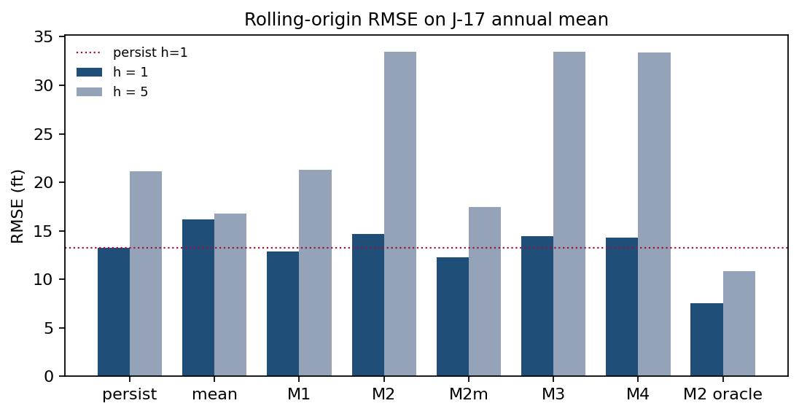
Figure 3
Figure 3. Rolling-origin RMSE. The oracle is excluded from retention.
Table 4. Rolling-origin summary (ft).
Model | $h=1$ RMSE | $h=1$ MAE | $h=5$ RMSE
persist | 13.23 | 10.73 | 21.11
mean | 16.17 | 13.17 | 16.80
M1 | 12.84 | 10.72 | 21.25
M2 | 14.70 | 11.45 | 33.49
M2m | 12.28 | 10.22 | 17.44
M3 | 14.46 | 11.12 | 33.46
M4 | 14.30 | 11.17 | 33.39
M2_oracle | 7.55 | 5.79 | 10.87
Full-sample correlations: $corr\left(H_{t},H_{t−1}\right)=0.64$ with AR(1) coefficient $\hat{φ}=0.66$; $corr\left(R_{t},R_{t−1}\right)=0.17$; $corr\left(ΔH_{t},R_{t}\right)=0.74$. Full-sample $\left(\hat{β},\hat{γ}\right)=\left(0.017,−0.026\right)$ have the expected signs when the sample is long. The water-balance class is not empty, but recharge is not persistent.
Table 5. Retention on rolling $h=1$ RMSE.
Model | Versus persist | Distinct structure | Decision
M1 | $12.84<13.23$ | output only | retained (margin 0.39 ft)
M2 | $14.70>13.23$ | causal fluxes | reject
M2m | $12.28<13.23$ | no (affine AR(1)) | list only; not extra structure
M3, M4 | worse than persist | yes | reject
M2_oracle | $7.55$ | uses future $R,P$ | excluded
M1 is retained by the point-RMSE rule. The margin is 0.39 ft on $n=75$. That is not a confirmation of stock-flow structure; it is a slightly mean-reverting head series. M2m is listed by the same rule and then demoted on class grounds fixed in the protocol (constant fluxes reduce it to AR(1)); its numerical advantage does not constitute additional structure. No stock-flow, residual, or delay module is retained.
At $h=5$, the training mean (16.80 ft) has lower RMSE than persistence (21.11 ft). Five-year forecasts on this basin are climatology, not last value and not persisted recharge.
On post-2007 origins only ($n=16$, $h=1$): persist 13.09, M1 12.16, M2 13.31, oracle 8.03. The ranking is unchanged. The 660-ft Brier scores are 0.31 (persist), 0.25 (M1), and 0.19 (oracle). At $h=5$ ($n=12$): persist 25.10, M1 17.16, M2m 17.64, mean 16.41, M2/M3/M4 34.9–35.0, oracle 8.69. The annual-mean proxy is not the 10-day rule.

5.4 Climate-informed recharge
Information known at 31 December of year $t$ comprises $R_{t}$, the September–November Niño 3.4 anomaly of year $t$, and calendar-year precipitation in Texas climate divisions 06 and 07. December–February precipitation that includes January of $t+1$ is not used.
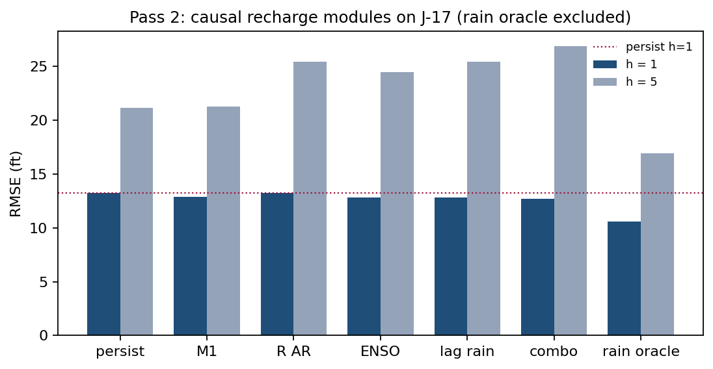
Figure 4
Figure 4. Rolling RMSE on J-17 for climate-informed recharge. The precipitation oracle uses year $t+h$ precipitation and cannot be retained.
Table 6. Rolling RMSE, climate-informed recharge.
Model | $H$, $h=1$ | $H$, $h=5$ | $R$, $h=1$ (${10}^{3}$ acre-ft)
persist $H$ / persist $R$ | 13.23 | 21.11 | 702
M1 | 12.84 | 21.25 | —
M2_Rar | 13.25 | 25.38 | 561
M2_Renso | 12.82 | 24.42 | 528
M2_Rprecip | 12.80 | 25.38 | 545
M2_combo | 12.71 | 26.88 | 538
rain climatology | — | — | 556
rain oracle | 10.56 | 16.91 | 354
Same-year $corr\left(R,\overset{‾}{P}\right)=0.78$, which is why the precipitation oracle reduces head RMSE to 10.56 ft. It remains worse than the full $\left(R,P\right)$ oracle (7.55 ft): the linear rain map misses 1957-scale extremes.
Lagged precipitation and September–November Niño 3.4 have modest skill on $R$ relative to climatology (528–545 versus 556 $×{10}^{3}$ acre-ft). They do not constitute forecast structure on $z$:
- the point-RMSE rule lists ENSO, lagged precipitation, and the combination (each less than persist and less than M1);
- margins versus M1 are 0.02, 0.04, and 0.13 ft;
- at $h=5$ all three have RMSE 3–6 ft higher than persistence;
- they are M2m with a weakly adjusted intercept and do not constitute additional forecast structure.
M2_Rar loses at $h=1$ (13.25 ft; 0.41 ft worse than M1). Autoregression on nearly white recharge is not a recharge forecast.
On the 1957–61 recovery, no causal climate-informed module has lower RMSE than persistence (persist 43.6 ft; best causal about 48.8 ft; precipitation oracle 33.7 ft). September–November 1956 is La Niña ($−0.92$) and does not announce $R_{1957}=1143$.
The remaining fixed windows complete the same record. Drawdown 1951–56: persist 23.75, M1 30.94, M2_Renso 24.30, M2_Rprecip 28.67, M2_combo 24.70, precipitation oracle 18.16 ft. Pre-permit wet 1991–95: persist 30.13, M1 20.02, M2_Rprecip 22.03, M2_Renso 23.03, M2_Rar 23.94, M2_combo 25.71, oracle 10.98 ft. Critical-period era 2015–23: persist 27.41, M1 15.62, M2_Rprecip 14.52, M2_Rar 14.67, M2_Renso 16.01, M2_combo 16.57, oracle 9.75 ft — on this one window the two climate-informed recharge modules edge past M1 by about one foot. On the recharge target itself the fixed-window scores are an order of magnitude coarser on every window (climate modules 199–937; precipitation oracle 80.7–487, against the 556 $×{10}^{3}$ acre-ft climatology scale of the rolling record), so the marginal head advantage is a window-specific result, not a recharge forecast.
No climate-informed recharge module is retained. Closing the gap between persistence and the oracle would require next year’s recharge, which is not available at the annual forecast origin.

5.5 Service series after freeze
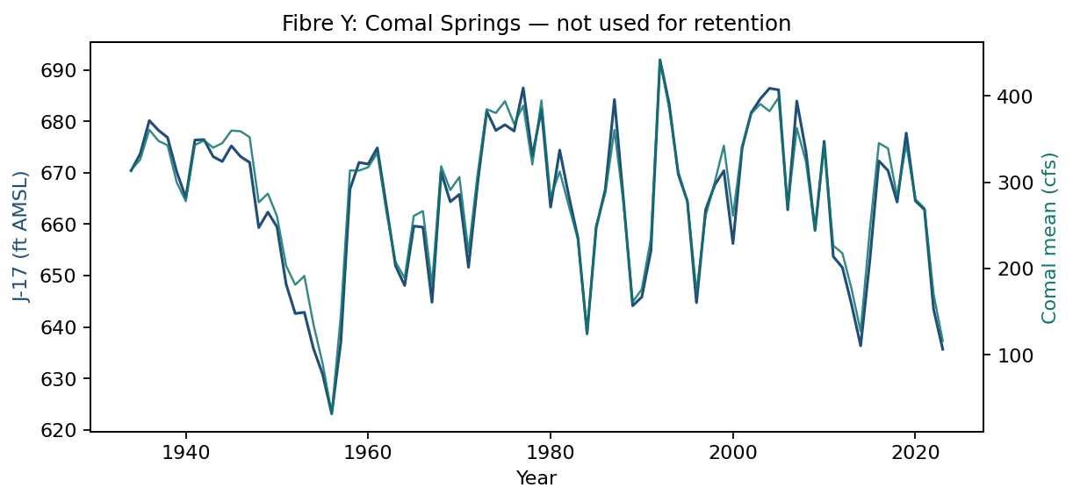
Figure 5
Figure 5. Comal annual mean versus J-17. Contemporaneous $r=0.986$. The service series — the observation fibre, a measured channel of the same state — is a measured service, not an independent information source.
The map $Q=c_{0}+c_{1}H$ was fitted on 1934–1950 only ($c_{0}=−2876$, $c_{1}=4.77$) and applied to already-issued $\hat{H}$. One-year Comal RMSE: persist 71.9 cfs, M1 69.0, M2m 68.7, M2 74.8, M3 73.8, M4 73.4, train-mean 89.7, oracle 45.3.
The service series does not change retention. It cannot: it is nearly a linear transform of $z$. Comal is an independent measurement (a USGS spring gauge, not used to construct J-17). It is not an independent information source. Gravimetric storage or the J-27 Uvalde index would be different objects, not a second fibre of this specification. Eastern-basin recharge was stored and not used.

6. Discussion
The one-pool increment $ΔH$ tracks recharge ($r=0.74$). Oracle RMSE is about half of persistence at both $h=1$ and $h=5$. The map accounts for contemporaneous increments when the year’s water is known.
As a one-year forecast, causal stock-flow fails because the dominant increment is not persistent. Residual and delayed variants inherit that timing error. Recoveries in 1957 and 1992 are missed by every causal model and captured by the oracle. The identified driver has the wrong timing for an annual origin: the same pattern appears in a companion evaluation on Northern cod (under separate review), where a more accurate catch series does not rescue constant-productivity surplus production. The two score tables are not pooled.
The 1950s decline is not a Stage I event. The 660 ft line is a 2007 rule. 1956 is a physical near-cessation at Comal (annual mean springflow 32 cfs; daily J-17 minimum 612.51 ft). Slack to 660 ft is the wrong leading indicator for 1951–56, just as the 2016 Northern cod limit reference point was the wrong leading indicator for 1983–90.
Two-pool exchange, solute, and barrier bookkeeping were not fitted and cannot be retained. In the two-pool parameterization, the relative-exchange term is removed, leakage is not applicable, and no barrier or exchange term is fitted; the blocking list is not closed by this paper. Post-1997 pumpage no longer spikes with drought as in 1956 (321 kaf wells); that change is already in $P_{t}$. A separate critical-period switch does not add a degree of freedom beyond the pumpage series.
Limitations follow the data and the map. The annual affine one-pool specification is not a karst model: conduits, the Uvalde–San Antonio divide, and unconfined recharge-zone storage remain in the residual. Total-area $R$ and $P$ mix the San Antonio and Uvalde pools; that is a declared approximation defect. Recharge is a Puente estimate; pumpage includes unreported domestic, livestock, and federal use. Neither series is $z$. M4 is a one-year information delay, not a set-valued conservative filter. The sample is 90 years with four short test windows; the 0.39 ft AR(1) margin is not a significance claim.
The evaluated specification is a one-pool approximation of the aquifer’s head map. It does not transfer an interval-verified linear template (a companion methodological study; that template is not this specification), does not instantiate a closed-loop information filter, and does not close the two-pool module. Model selection used $z$ only. No result is treated as established without specification matching and independent verification.
On this evidence, modules that are not identified on the training data, or whose drivers arrive too late to be causal at the annual origin, do not reduce forecast error. The retained forecast is persistence with a small AR(1) correction; the water-balance map serves as a certificate for a year whose recharge is already known.

7. Conclusions
On locked J-17 annual-mean head, last-value persistence is more accurate than a causal one-pool balance that persists last year’s recharge. Univariate AR(1) improves one-year RMSE by 0.39 ft and is retained as an output-only model. The same balance, given realized recharge and pumpage, cuts error nearly in half. Climate variables known at the annual origin do not recover that gap.
The paper reports a forecast comparison. It does not conclude that the aquifer is unsustainable, and it does not conclude that the evaluation framework is empirically confirmed on this basin.
Reopening the climate module with additional indices (PDO, AMO) on this annual origin would re-instantiate the rejected structure; a mid-year nowcast would require a new evaluation protocol.

Data and code availability
All input data, analysis scripts, and result files are archived in the research programme’s public repository at https://github.com/MIKEAA2020/general-sustainability; an anonymized copy of the full artifact set is available for double-anonymous review, and the full frozen model specification is archived with them. J-17 daily highs: Texas Water Development Board well 6837203. Recharge: Umphres and Choi (2025), DOI 10.5066/P1BI62NY. Pumpage: Edwards Aquifer Authority (2024/25), Table 1. Comal Springs: USGS 08168710. Niño 3.4: NOAA PSL HadISST (raw file data/psl_nino34_long.data, committed with the repository). Precipitation: NCEI nClimDiv climdiv-pcpndv-v1.0.0-20260806 — not distributed with the repository (provenance URL in data/SOURCES.md); the three pcp_* columns of the fixed panel are therefore not reproducible from the committed code alone, while the two Niño columns rebuild from the committed PSL file to machine precision. Scoring Pass 1/2 from the committed data/annual_panel.csv does not require the nClimDiv file. All computations are deterministic: re-executing the committed scripts in a fresh environment regenerated every archived result file byte for byte, and all scored rows recompute from the per-observation forecast files and the committed series. The scoring protocols (Pass 1 and Pass 2) and the companion intervention-selection protocol are dated 2026-08-25 and 2026-08-26 respectively — locked before any score was generated — and are archived with the code as the preregistration record.
python3 src/run_ladder.py && python3 src/run_recharge.py
python3 src/make_figures.py
The committed twenty-column analysis panel (data/annual_panel.csv) is the dataset of record for all scored analyses. The panel-construction script re-derives the head, recharge, and pumpage columns from the primary sources and leaves the fixed twenty-column panel in place when the re-derived columns already match. build_climate.py rebuilds the two Niño 3.4 columns from the committed PSL raw file (nino34.long.data); rebuilding the three precipitation columns additionally requires the nClimDiv file (climdiv-pcpndv-v1.0.0-20260806), which is not distributed with the repository, and leaves the fixed panel in place when those columns already match.

References
Adamowski, J., and Chan, H. F. 2011. A wavelet neural network conjunction model for groundwater level forecasting. Journal of Hydrology 407: 28–40.
Daliakopoulos, I. N., Coulibaly, P., and Tsanis, I. K. 2005. Groundwater level forecasting using artificial neural networks. Journal of Hydrology 309: 229–240.
Edwards Aquifer Authority. 2024/25. 2023 Groundwater Discharge and Usage. Table 1, after USGS letter report 5 April 2024. https://www.edwardsaquifer.org/wp-content/uploads/2025/05/2023-Groundwater-Discharge-and-Usage.pdf
Edwards Aquifer Authority. Critical Period / Drought Management. https://www.edwardsaquifer.org/groundwater-users/critical-period-drought-management/
Makridakis, S., Spiliotis, E., and Assimakopoulos, V. 2020. The M4 Competition: 100,000 time series and 61 forecasting methods. International Journal of Forecasting 36: 54–74.
NOAA National Centers for Environmental Information. nClimDiv precipitation, file climdiv-pcpndv-v1.0.0-20260806. https://www.ncei.noaa.gov/pub/data/cirs/climdiv/climdiv-pcpndv-v1.0.0-20260806
NOAA Physical Sciences Laboratory. Niño 3.4 monthly SST (HadISST). https://psl.noaa.gov/data/timeseries/month/data/nino34.long.data
Puente, C. 1978. Method of estimating natural recharge to the Edwards Aquifer in the San Antonio area, Texas. U.S. Geological Survey.
Ropelewski, C. F., and Halpert, M. S. 1986. North American precipitation and temperature patterns associated with the El Niño/Southern Oscillation (ENSO). Monthly Weather Review 114: 2352–2362.
Scanlon, B. R., Mace, R. E., Barrett, M. E., and Smith, B. 2003. Can we simulate regional groundwater flow in a karst system using equivalent porous media models? Case study, Barton Springs Edwards aquifer, USA. Journal of Hydrology 276: 137–158.
Texas Water Development Board. Water Data for Texas, well 6837203 (J-17). https://waterdatafortexas.org/groundwater/well/6837203
Umphres, G. D., and Choi, N. J. 2025. Estimated Annual Recharge to the Edwards Aquifer in the San Antonio Area, by Stream Basin or Ungaged Area, 1934–2024. U.S. Geological Survey data release. https://doi.org/10.5066/P1BI62NY
U.S. Geological Survey. National Water Information System, site 08168710, Comal Springs at New Braunfels, Texas.

